RP-ALARA Association Meeting Agenda

Chattanooga Tennessee - June 2021



**Sunday, June 13**

4:00 – 6:00 pm Steering Board Members - Pre-Meeting & Appetizers

**Note To all the RP-ALARA Association Representatives:**

This is to inform you that the RP-ALARA Association Meeting has been granted 1 CEC per contact hour to a maximum of 20 CEC and assigned ID 2019-00-001. This credit applies to calendar years 2020-2022.

Please be advised that contact hours do not include meals or business meetings without technical content.

As credit was requested for all participants, this assignment will be posted to the AAHP website.

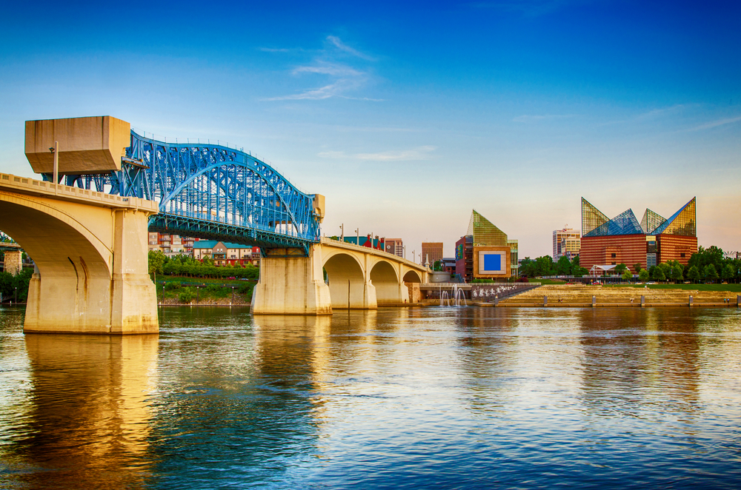

**Monday, June 14**

2:00 – 2:30 pm Meeting Registration –

2:30 – 3:15 pm Opening Ceremonies & Introduction in:

* + - * Welcome – Opening Remarks (Jeff Fontaine)
      * Safety Review – Building Escape Routes (Joe Coughlin)
      * Safety Message – (Joe Coughlin)
      * Introduction of NSA Representative – (Rick McCormick)
      * Introductions of Board Members (Jeff Fontaine)
      * Introduction of Association Members (All)
      * Association Secretary Report (Jeff Fontaine)
      * Association Treasury Report (Kinsey Boehl)
      * Establish Meeting Expectations/Review Agenda & Meeting Book Contents (Jeff Fontaine)
      * Bench Mark Question Solicitation & High Interest Topic Sheets (Joe Coughlin)
      * Introduction of Host Plant (Nine Mile-Bill Scarberry)
      * Elections this meeting (Jeff Fontaine)

3:15 – 4:15 pm Presentation

4:15 – 4:20 pm Adjourn Day 1 (Jeff Fontaine)

4:30 – 4:50 pm Steering Committee Meeting

5:00 – 6:30 pm Opening Reception & Vendor Displays

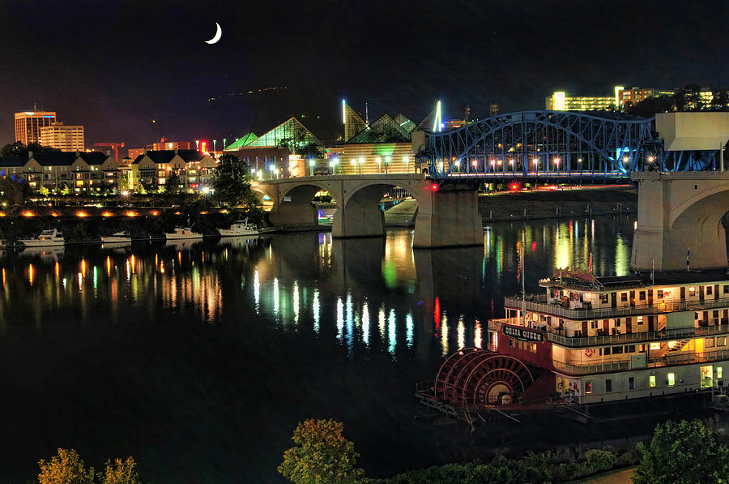

**Tuesday, June 15**

**07:00 – 08:00 Breakfast with Vendors**

08:00 – 08:05 Meeting Overview (Jeff Fontaine)

08:05 – 08:10 Safety Message (Kinsey Boehl)

08:10 – 08:20 Association Group Picture

08:20 – 09:40 Breakout Sessions by Plant Type (Document Successes & Challenges and a Golden Nugget)

* + - * 2 Loop & 3 Loop Westinghouse (Jeff Fontaine)
      * 4 Loop Westinghouse Group 1 (Joe Coughlin)
      * 4 Loop Westinghouse Group 2 (Bob French)
      * B & W, CE and BWR’s (Lloyd Frink, Bill Scarberry)
      * ICE (Kinsey Boehl)

09:40 – 10:00 **Break / Vendor Interface (Report to Break out Rooms after break)**

10:00 – 11:30 Breakout Session by Plant Type (Document Successes & Challenges and a Golden Nugget)

* + - * 2 Loop & 3 Loop Westinghouse (Jeff Fontaine)
      * 4 Loop Westinghouse Group 1 (Joe Coughlin)
      * 4 Loop Westinghouse Group 2 (Bob French)
      * B & W, CE and BWR’s (Lloyd Frink, Bill Scarberry)
      * ICE (Kinsey Boehl)

11:30 - 11:40 **10 Minute Break (Report to conference room after break)**

11:40 – 12:30 Vendor Presentations

12:30 – 1:30 **Lunch**

1:30 – 2:30 Presentation

2:30 – 2:45 **15 Minute Break**

2:45 – 3:40 Vendor Presentations (Remaining vendors)

3:40 – 3:50 End of Day Comments / Adjourn Day 2

4:00 – 4:30 Steering Committee Meeting

5:00 – 6:30 Vendor Reception

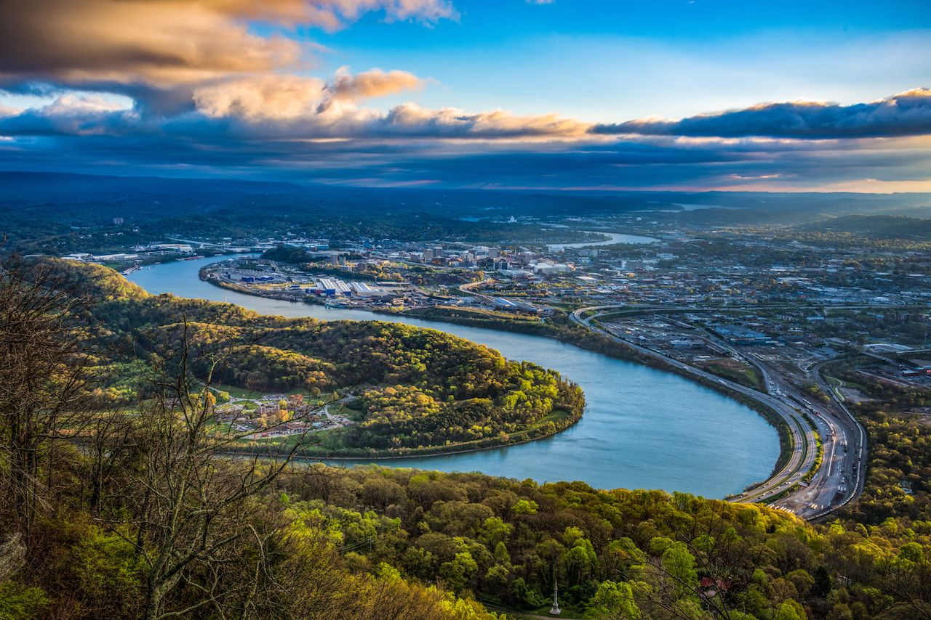

**Wednesday, June 16**

07:30 – 08:30 Breakfast with Vendors

08:30 – 08:35 Safety Message (Lloyd Frink)

08:35 – 09:40 Breakout Session Review (Successes, Challenges and Golden Nuggets)

09:40 – 09:50 **10 Minute Break**

09:50 – 10:35 Continue Breakout Session Review (Successes, Challenges and Golden Nuggets)

10:35 – 11:00 **Break / Vendor Interface**

11:00 – 12:00 Continue Breakout Session Review (Successes, Challenges and Golden Nuggets)

12:00 – 1:10 **Lunch /** **Passport Drawing**

1:10 – 2:10 Complete Breakout Session Review (Successes, Challenges and Golden Nuggets)

2:10 – 2:20 **10 Minute Break**

2:20 – 3:00 Round Table Discussions

3:00 – 3:15 Closing Remarks and Update on 2022 Winter Meeting (Key West Florida )

**January 2022**

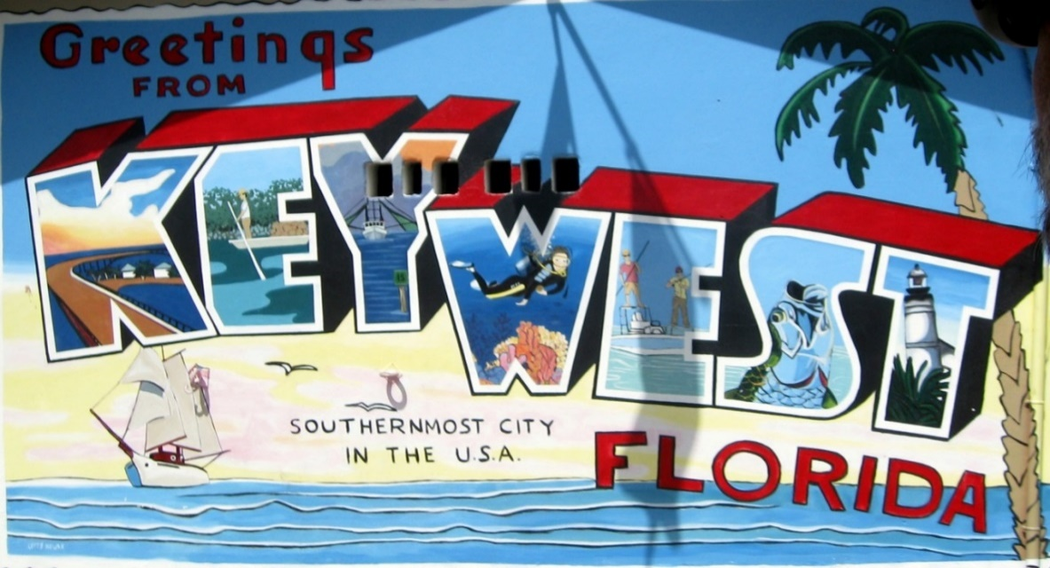

3:30 – 4:30 Steering Committee Post-Meeting

* Opening Remarks
* Welcome New Members
* Review Meeting Critique Sheets
* New Business