RP-ALARA Association Meeting Agenda

Key West Florida - January 2022

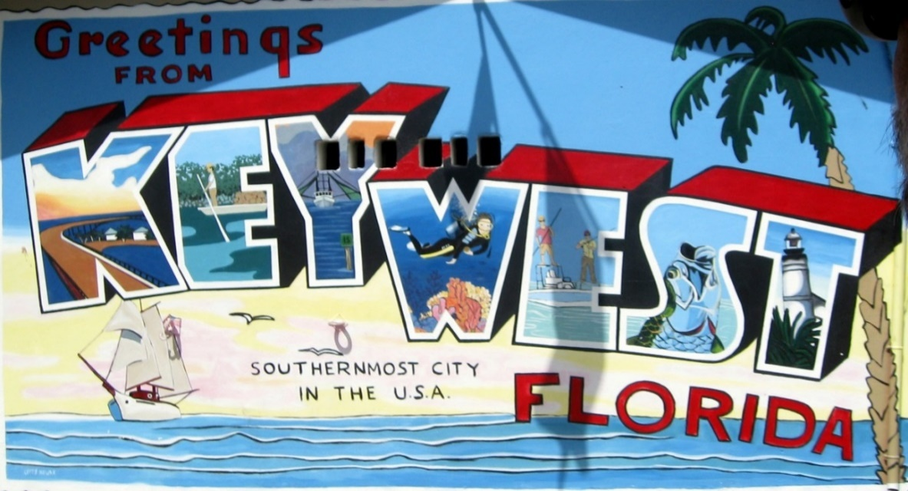

**Sunday, January 23**

4:00 – 6:00 pm Steering Board Members - Pre-Meeting & Appetizers

**Note To all the RP-ALARA Association Representatives:**

This is to inform you that the RP-ALARA Association Meeting has been granted 1 CEC per contact hour to a maximum of 20 CEC and assigned ID 2019-00-001. This credit applies to calendar years 2019-2022.

Please be advised that contact hours do not include meals or business meetings without technical content.

As credit was requested for all participants, this assignment will be posted to the AAHP website.

**Monday, January 24**

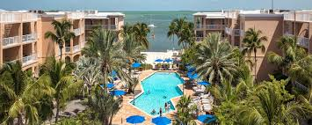

2:00 – 2:30 pm Meeting Registration with DeeDee McNeill – All

2:30 – 3:15 pm Opening Ceremonies & Introduction

* + - * Welcome – Opening Remarks (Jeff Fontaine)
      * Safety Review – Building Escape Routes (Joe Coughlin)
      * Safety Message – (Joe Coughlin)
      * Introduction of NSA Representative – (Rick McCormick)
      * Introductions of Board Members (Jeff Fontaine)
      * Introduction of Association Members (All)
      * Association Secretary Report (Bob French)
      * Association Treasury Report (Kinsey Boehl)
      * Establish Meeting Expectations/Review Agenda & Meeting Book Contents (Jeff Fontaine)
      * Benchmark Question Solicitation & High Interest Topic Sheets (Joe Coughlin)
      * Elections this meeting (Jeff Fontaine)

3:15 – 4:15 pm Presentation (INPO update, contingent)

4:15 – 4:20 pm Adjourn Day 1 (Jeff Fontaine)

4:30 – 4:50 pm Steering Committee Meeting

5:00 – 6:30 pm Opening Reception & Vendor Displays

**Tuesday, January 25**

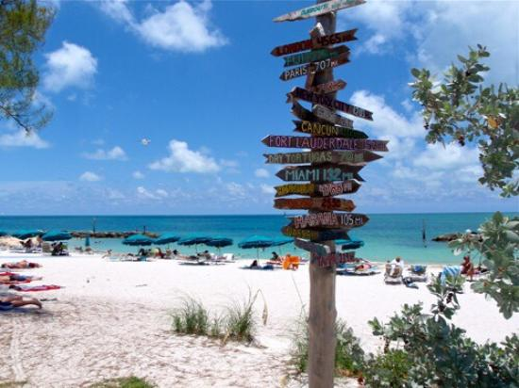

**07:00 – 08:00 Breakfast with Vendors**

08:00 – 08:05 Meeting Overview (Jeff Fontaine)

08:05 – 08:10 Safety Message (Joe Coughlin)

08:10 – 08:20 Association Group Picture

08:20 – 09:40 Breakout Sessions by Plant Type (Document Successes & Challenges and a Golden Nugget)

* + - * 2 Loop & 3 Loop Westinghouse (Jeff Fontaine)
      * 4 Loop Westinghouse (Joe Coughlin)
      * B&W, CE, ICE, and BWR’s (Steve Edelman)
      * 4 Loop Westinghouse (Bob French)

09:40 – 10:00 **Break / Vendor Interface (Report to Break out Rooms after break)**

10:00 – 11:30 Breakout Session by Plant Type (Document Successes & Challenges and a Golden Nugget)

* + - * 2 Loop & 3 Loop Westinghouse (Jeff Fontaine)
      * 4 Loop Westinghouse (Joe Coughlin)
      * B&W, CE, ICE, and BWR’s (Steve Edelman)
      * 4 Loop Westinghouse (Bob French)

11:30 - 11:40 **10 Minute Break (Report to conference room after break)**

11:40 – 12:30 Vendor Presentations

12:30 – 1:30 **Lunch**

1:30 – 2:30 Vendor Presentations

2:30 – 2:45 **15 Minute Break**

2:45 – 3:40 Vendor Presentations (Remaining vendors)

3:40 – 3:50 End of Day Comments / Adjourn Day 2 (Jeff Fontaine)

4:00 – 4:30 Steering Committee Meeting

5:00 – 6:30 Vendor Reception

**Wednesday, January 26**

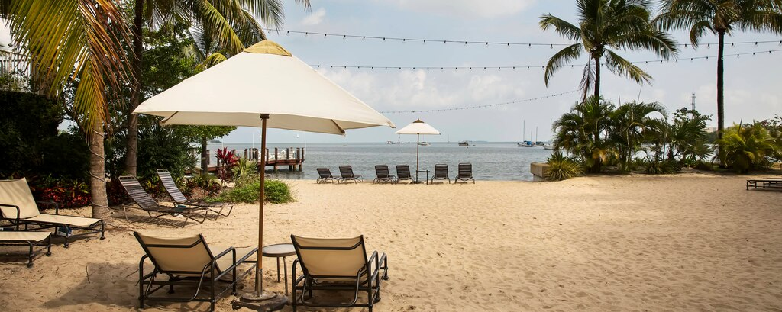

07:30 – 08:30 Breakfast with Vendors

08:30 – 08:35 Safety Message (Bob French)

08:35 – 09:40 Breakout Session Review (Successes, Challenges and Golden Nuggets)

09:40 – 09:50 **10 Minute Break**

09:50 – 10:35 Continue Breakout Session Review (Successes, Challenges and Golden Nuggets)

10:35 – 11:00 **Break / Vendor Interface**

11:00 – 12:00 Continue Breakout Session Review (Successes, Challenges and Golden Nuggets)

12:00 – 1:10 **Lunch /** **Passport Drawing**

1:10 – 2:10 Complete Breakout Session Review (Successes, Challenges and Golden Nuggets)

2:10 – 2:20 **10 Minute Break**

2:20 – 3:00 Round Table Discussions (Jeff Fontaine)

3:00 – 3:15 Closing Remarks and Update on 2022 Summer Meeting in Chattanooga Tennessee (Jeff Fontaine)

**June 6-8, 2022**



3:30 – 4:30 Steering Committee Post-Meeting

* Opening Remarks
* Welcome New Members
* Review Meeting Critique Sheets
* New Business