 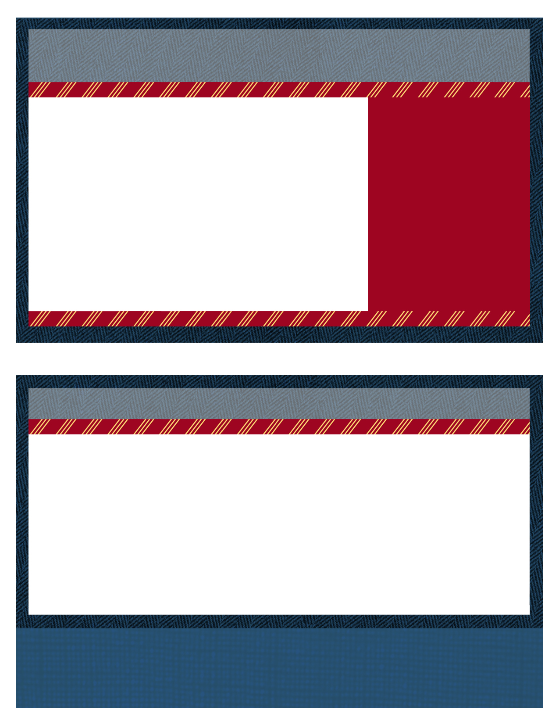

|  |  |
| --- | --- |
|  | If you have any questions or comments regarding the meeting please feel free to contact DeeDee McNeil at any of the below addresses or telephone numbers.  **DeeDee McNeill**, Nuclear Suppliers Association **Phone**: (401) 637-4224  **E-mail**: deedeemcneill@nuclearsupplier.org |

**Board of Directors**

Chairman – Jeff Fontaine

[fontainej@energyharbor.com](mailto:fontainej@energyharbor.com)

Vice Chairman – Joe Coughlin

joseph.coughlin@exeloncorp.com

Secretary -Bob French

(bofrenc@WCNOC.com)

Treasurer - Kinsey Boehl

kinsey.boehl@nexteraenergy.com

**Steering Board**

Steve Edelman

Steven.Edelman@exeloncorp.com

Dave Martin

david.r.martin@xcelenergy.com

William Scarberry

William.Scarberry@ge.com

Open Position

**Key West**

[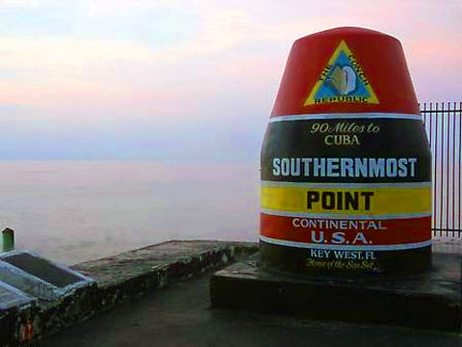](http://www.google.com/url?sa=i&rct=j&q=&esrc=s&source=images&cd=&cad=rja&uact=8&ved=0ahUKEwj9x4qmycrJAhUX22MKHYJhAVcQjRwIBw&url=http://keystv.com/dynamic/index.php?id%3D814&psig=AFQjCNHf9EX9HilxETZcyIJZILNl_dMg6g&ust=1449605671525188)

**RP-ALARA Association Vision:** The RP-ALARA Association is committed to continual improvement in radiation protection standards and performance at our utilities.

2022 RP-ALARA Association Meeting

Key West, FL

Mon. January 24 - Wed. January 26, 2022

News for New and Returning Members

While many of you are longstanding attendees of the RP-ALARA Association meetings, some of you may be attending for the first time. We would like to take this opportunity to provide you with information that will assist you in preparing for this meeting.

The RP-ALARA Association Conference is designed to facilitate the open sharing of industry knowledge through Operational Experience. The Association continually evaluates industry products and services with exposure impacts and shares experiences: e.g., shutdown chemistry, operating chemistry, chemical decon, zinc injections, micro filtration, and mechanical decon equipment to effectively manage our individual utility resources.

At this meeting, you will find industry best practices for site dose ownership, compare dose reduction strategies utilized at represented utilities, and obtain new ideas in regard to motivating and recognizing the work force to reduce overall site exposure.

We hope this interface with other ALARA members to make industry contacts, share knowledge and gain strategies will help further reduce exposures at your facility.

Welcome to the 2022 RP-ALARA Association Meeting

2nd Day Agenda -Tuesday, January 25

**07:00 – 08:00 Breakfast with Vendors**

08:00 – 08:05 Meeting Overview

(Jeff Fontaine)

08:05 – 08:10 Safety Message

(Joe Coughlin)

08:10 – 08:20 Association Group Picture

08:20 – 09:40 Breakout Sessions by Plant Type (Document Successes & Challenges and a Golden Nugget)

* + - * 2 Loop & 3 Loop Westinghouse (Jeff Fontaine)
      * 4 Loop Westinghouse (Joe Coughlin)
      * B&W, CE, ICE, and BWR’s (Steve Edelman)
      * 4 Loop Westinghouse (Bob French)
      * BWR’s

(Bill Scarberry)

1st Day Agenda - Monday , January 24

Things to Consider:

* Benchmark question solicitation - Typically the group makes a list of 3 - 4 questions, which will be discussed roundtable fashion later in the meeting. Please consider if you have a question that where you would like industry feedback.
* High Interest Topic Sheets - Another way to solicit industry feedback. Just list your question on a provided form and we will pass it around to gather answers.
* Vendor Presentations - A short presentation from each vendor.
* Breakout Session (Document Successes) - What works well at your plant? Please come prepared to share at least two items during this session.

Special Note: We want to welcome your family and traveling companions to join us for lunch and after meeting (evening) receptions!



2:00 to 2:30 Meeting Registration with DeeDee McNeill – All

2:30 – 4:20 pm Opening Ceremonies & Introduction

* + - * Welcome – Opening Remarks (Jeff Fontaine)
      * Safety Review – Building Escape Routes (Joe Coughlin)
      * Safety Message – (Joe Coughlin)
      * Introduction of NSA Representative – (Rick McCormick)
      * Introductions of Board Members (Jeff Fontaine)
      * Introduction of Association Members (All)
      * Association Secretary Report (Bob French)
      * Association Treasury Report (Kinsey Boehl)
      * Establish Meeting Expectations/Review Agenda & Meeting Book Contents (Jeff Fontaine)
      * Benchmark Question Solicitation & High Interest Topic Sheets (Joe Coughlin)
      * Elections this meeting (Jeff Fontaine)

3:15 – 4:15 pm Presentation (INPO update, contingent)

4:15 – 4:20 pm Adjourn Day 1 (Jeff Fontaine)

4:30 – 4:50 pm Steering Committee Meeting

5:00 – 6:30 pm Opening Reception & Vendor Displays

C:\Documents and Settings\dlp8236\Local Settings\Temporary Internet Files\Content.IE5\WQXX73G0\MC900024040[1].wmf *C:\Documents and Settings\dlp8236\Local Settings\Temporary Internet Files\Content.IE5\B8PH5033\MC900241089[1].wmf C:\Documents and Settings\dlp8236\Local Settings\Temporary Internet Files\Content.IE5\ISDIQPTK\MC900242025[1].wmf*

2022 RP-ALARA Association Meeting

Suggestions on Technical Presentations or specific speakers are welcome.

More Things to Think About:

Breakout Session (Document Challenges & a Golden Nugget) - What is your site's biggest challenge? Please come prepared to share this item.

AND what one thing do you consider your site does well...perhaps you have some new process you have determined works really well or you've discovered some new technology...that just may be your Golden Nugget. (Typically, Golden Nuggets are inexpensive and easy to implement)

MC900216564[1]

Please come prepared to discuss your Golden Nugget.

10:00 – 11:30 Breakout Session by Plant Type (Document Successes & Challenges and a Golden Nugget)

* + - 2 Loop & 3 Loop Westinghouse (Jeff Fontaine)
    - 4 Loop Westinghouse - will break out into 2 groups (Kinsey Boehl )
    - 4 Loop ICE (Bob French)
    - B & W, CE and Decommissioning Units (Steve Edelman)
    - BWR’s (Bill Scarberry)

11:30 - 11:40 **10 Minute Break (Report to Salon C after break)**

11:40 – 12:30 Vendor Presentations

12:30 – 1:30 **Lunch**

1:30 – 2:30 Vendor Presentations

2:30 – 2:40 **10 Minute Break**

2:40 – 3:30 Vendor Presentations (Remaining vendors)

3:30 – 3:40 Vote for New Board Member

3:40 – 3:50 End of Day Comments / Adjourn Day 2

4:00 – 4:30 Steering Committee Meeting

5:00 – 6:30 Vendor Reception & Vendor Displays in Salon A & B

* [**RP/ALARA - Association Vision and Principles**](http://www.pwralara.org/code-vision.htm)
* [**RP/ALARA - Association By-Laws**](http://www.pwralara.org/docs/PWR-ALARA-bylaws.doc)
* [**VENDOR - Code of Conduct**](http://www.pwralara.org/code-vendor.htm)
* [**RP/ALARA - Board of Directors Code of Conduct**](http://www.pwralara.org/code-steering.htm)

Will enter more data here

See RP-ALARA Website for additional rp alara information

2022 RP/ALARA Association Meeting

[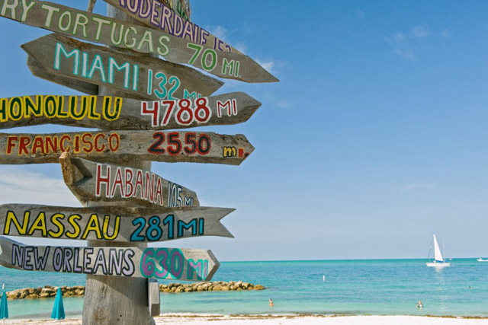](http://www.google.com/url?sa=i&rct=j&q=&esrc=s&source=images&cd=&cad=rja&uact=8&ved=0ahUKEwie_vS5yMrJAhUQw2MKHdN_CbAQjRwIBw&url=http://keywest.com/todo.html&psig=AFQjCNHf9EX9HilxETZcyIJZILNl_dMg6g&ust=1449605671525188)

2nd Day Agenda Continued...

Make sure you visit all Vendor Displays! Ensure your passport is signed for each display to be eligible for Passport Drawing prizes on Wednesday.

2:10 – 2:20 **Break**

2:20 – 3:00 Round Table Discussions

3:00 – 3:15 Closing Remarks

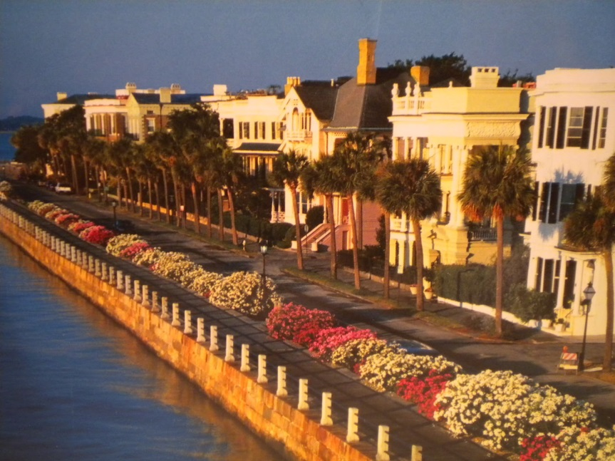

Chattanooga TN June 6-8 2022

3:30 – 4:30 Steering Committee Post-Meeting

* Opening Remarks
* Welcome New Members
* Review Meeting Critique Sheets
* New Business

08:00 – 09:00 Breakfast with Vendors

09:00 – 09:03 Safety Message (Bob French)

09:03 – 09:05 Voting Results for New Board Member (Jeff Fontaine)

09:05 – 10:35 Breakout Session Review (Successes, Challenges & Golden Nuggets)

* 4 Loop Westinghouse (K. Boehl)

10:35 – 11:00 **Break / Vendor Interface**

11:00 – 12:00 Breakout Session Review (Successes, Challenges & Golden Nuggets)

* 2 Loop & 3 Loop Westinghouse (J. Fontaine)

12:00 – 1:10 **Lunch /** **Passport Drawing**

1:10 – 2:10 Breakout Session Review (Successes, Challenges and Golden Nuggets)

* 4 Loop ICE (Bill Scarberry)
* B & W, CE and Decommissioning Units (Steve Edelman)

3rd Day Agenda - Wednesday, January 26

What other information would you like to see in this newsletter?

Please contact Jeff Fontaine @ fontainej@energyharbor.com to provide feedback.

Thanks so much!

Please visit RP-ALARA.org for additional information. The official information source for RP- ALARA Association Members contains many useful links to web sites related to Nuclear Energy and other related sites.

We hope you have found this information to be useful in helping you prepare for your trip. We look forward to seeing you in January!

**2022 RP/ALARA Association Meeting**