**Objective:**

The purpose of this document is to determine the feasibility of using a Sentinel Small Controlled Area Radiography (SCAR) unit for radiography applications at Watts Bar Nuclear Power Plant. The main benefit in using this unit is to further protect the worker by reducing the exclusion zone established while performing radiography.

**Stakeholders:**

WBN Radiation Protection Manager

WBN Outage Manager

**Overview:**

The source in the SCAR unit travels only several inches from storage to the collimated window (Figure 1). This design ensures the source is shielded for the majority of the exposure time. The collimated window allows an approximate 40-degree exposure path (Figure 2)

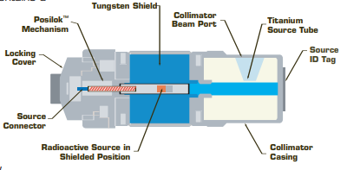

Figure 1

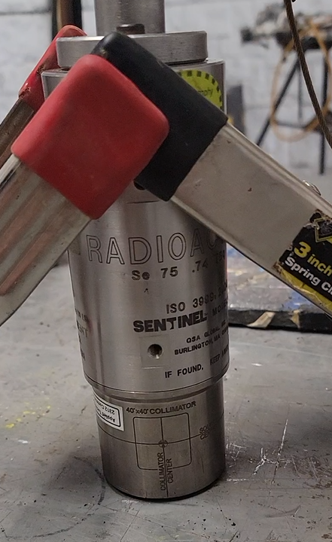

Figure 2

6 DMC 2000 electronic dosimeters with remote transmitters were source checked and placed 12 inches away from SCAR housing. One was placed North, East, South, and West of the housing, one directly above, and the last one directly below. An AMP-100 was place one foot away between the East and South dosimeters (Figure 3). A remote read out station was used to record these readings during source exposure. The beam direction was towards the North dosimeter

The SCAR housing contained a 6.75 Ci Se-75 source. The calculated dose rates, using RadPro Calculator, at 1 foot for this source is approximately 14,000 mRem/hr.



Figure 3

The following samples of Silflex shielding were applied during exposures:

* Sample A (SA1) – A layer of Magnetic backing, followed with tungsten, then a layer of magnetic backing
* Sample B (SB2) - A layer of Magnetic backing, followed with a tungsten/Iron composite
* Sample C (SC3) - A layer of Magnetic backing, followed with a tungsten.

**Exposures:**

Exposure was performed using the SCAR unit. The North Wall reading is directly in line with the source window

1. One open air to obtain a baseline (Exp 1) with the following results:

|  |  |  |  |  |  |  |  |  |
| --- | --- | --- | --- | --- | --- | --- | --- | --- |
|  | Shielding | Overhead | East Wall | West Wall | North Wall | South Wall | Bottom | AMP-100 |
| Exp 1 | None | 0.3 | 68 | 51 | 7600 | 11 | 34 | 15 |
| Table 1 |  |  | (All Dose Rates in mRem/hr) | | |  |  |  |
|  | | | | | | | | |

1. One with a 6-inch steel pipe cut-out that simulates the Aux Feedwater piping radiography (Exp 2).



Figure 4

|  |  |  |  |  |  |  |  |  |
| --- | --- | --- | --- | --- | --- | --- | --- | --- |
|  | Shielding | Overhead | East Wall | West Wall | North Wall | South Wall | Bottom | AMP-100 |
| Exp 2 | Pipe | 0.3 | 41 | 151 | 1250 | 7 | 31 | 44 |
| Table 2 |  |  | (All Dose Rates in mRem/hr) | | |  |  |  |

1. Four additional exposures were performed on the steel pipe cut out with shielding applied.
   * One with a layer of SA1 applied (Exp 3)

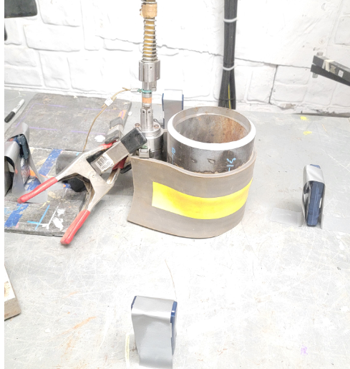

Figure 5

|  |  |  |  |  |  |  |  |  |
| --- | --- | --- | --- | --- | --- | --- | --- | --- |
|  | Shielding | Overhead | East Wall | West Wall | North Wall | South Wall | Bottom | AMP-100 |
| Exp 3 | Pipe&SA1 | 0.3 | 12 | 8 | 431 | 4 | 40 | 4 |
| Table 3 |  |  | (All Dose Rates in mRem/hr) | | |  |  |  |

* + One with a layer of SB2 applied (Exp 4)

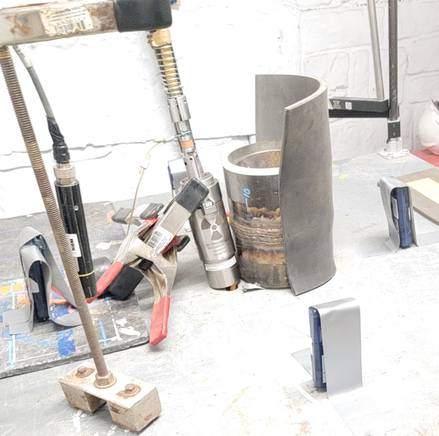

Figure 6

|  |  |  |  |  |  |  |  |  |
| --- | --- | --- | --- | --- | --- | --- | --- | --- |
|  | Shielding | Overhead | East Wall | West Wall | North Wall | South Wall | Bottom | AMP-100 |
| Exp 4 | Pipe&SB2 | 0.3 | 73 | 60 | 288 | 5 | NA | 35 |
| Table 4 |  |  | (All Dose Rates in mRem/hr) | | |  |  |  |

The null value was the result of a dosimeter shift and was therefore unreliable

* + One with a layer of SC3 applied (Exp 5)

|  |  |  |  |  |  |  |  |  |
| --- | --- | --- | --- | --- | --- | --- | --- | --- |
|  | Shielding | Overhead | East Wall | West Wall | North Wall | South Wall | Bottom | AMP-100 |
| Exp 5 | Pipe&SC3 | 0.3 | 96 | 58 | 400 | 6 | 22 | 35 |
| Table 5 |  |  | (All Dose Rates in mRem/hr) | | |  |  |  |

* + One with a layer of SB2 and SC3 applied (Exp 6)

|  |  |  |  |  |  |  |  |  |
| --- | --- | --- | --- | --- | --- | --- | --- | --- |
|  | Shielding | Overhead | East Wall | West Wall | North Wall | South Wall | Bottom | AMP-100 |
| Exp 6 | Pipe&SB2&SC3 | 0.3 | 72 | 63 | 131 | 7 | NA | 26 |
| Table 6 |  |  | (All Dose Rates in mRem/hr) | | |  |  |  |

The null value was the result of a dosimeter shift and was therefore unreliable

|  |  |  |  |  |  |  |  |  |
| --- | --- | --- | --- | --- | --- | --- | --- | --- |
| **Results Summary:**  The following table captures the results for exposures taken on the steel pipe cut-out. The 2 null values were the result of dosimeter shifts and were therefore unreliable  l Dose Rates in mRem/hr | | | | | | | | |
|  | Shielding Configuration | Overhead | East Wall | West Wall | North Wall | South Wall | Bottom | AMP-100 |
| Exp 1 | None | 0.3 | 68 | 51 | 7600 | 11 | 34 | 15 |
| Exp 2 | Pipe | 0.3 | 41 | 151 | 1250 | 7 | 31 | 44 |
| Exp 3 | Pipe&SA1 | 0.3 | 12 | 8 | 431 | 4 | 40 | 4 |
| Exp 4 | Pipe&SB2 | 0.3 | 73 | 60 | 288 | 5 | NA | 35 |
| Exp 5 | Pipe&SC3 | 0.3 | 96 | 58 | 400 | 6 | 22 | 35 |
| Exp 6 | Pipe&SB2&SC3 | 0.3 | 72 | 63 | 131 | 7 | NA | 26 |
|  | Table 7 | | | | | | | |
| Note: The North Wall reading is directly in line with the source window | | | | | |  |  |  |

1. Exposures were then performed with a steel sheet the same thickness as WBN Shield building container and approximately the same thickness as the Main Steam piping. (Exp 7)

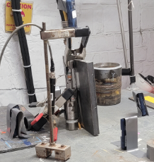

Figure 7

|  |  |  |  |  |  |  |  |  |
| --- | --- | --- | --- | --- | --- | --- | --- | --- |
|  | Shielding | Overhead | East Wall | West Wall | North Wall | South Wall | Bottom | AMP-100 |
| Exp 7 | Plate | 0 | 41 | 23 | 820 | 11 | 55 | 52 |
| Table 8 |  |  | (All Dose Rates in mRem/hr) | | |  |  |  |

1. Two additional exposures were performed on the steel sheet with shielding applied:
   * One with a layer of SC3 applied (Exp 8)

|  |  |  |  |  |  |  |  |  |
| --- | --- | --- | --- | --- | --- | --- | --- | --- |
|  | Shielding | Overhead | East Wall | West Wall | North Wall | South Wall | Bottom | AMP-100 |
| Exp 8 | Plate&SC3 | 0 | 34 | 7 | 277 | 8 | 29 | 35 |
| Table 9 |  |  | (All Dose Rates in mRem/hr) | | |  |  |  |

* + One with a layer of SB2 and SC3 applied (Exp 9)

|  |  |  |  |  |  |  |  |  |
| --- | --- | --- | --- | --- | --- | --- | --- | --- |
|  | Shielding | Overhead | East Wall | West Wall | North Wall | South Wall | Bottom | AMP-100 |
| Exp 9 | Plate&SC3&SB2 | 0 | 39 | 7 | 110 | 6 | 33 | 35 |
| Table 10 |  |  | (All Dose Rates in mRem/hr) | | |  |  |  |

**Results Summary:**

The following table captures the results for exposures taken on the steel plate.

|  |  |  |  |  |  |  |  |  |
| --- | --- | --- | --- | --- | --- | --- | --- | --- |
| All Dose Rates in mRem/hr | | | | | | | | |
|  | Shielding Configuration | Overhead | East Wall | West Wall | North Wall | South Wall | Bottom | AMP-100 |
| Exp 7 | Plate | 0 | 41 | 23 | 820 | 11 | 55 | 52 |
| Exp 8 | Plate&SC3 | 0 | 34 | 7 | 277 | 8 | 29 | 35 |
| Exp 9 | Plate&SC3&SB2 | 0 | 39 | 7 | 110 | 6 | 33 | 35 |
|  | Table | | | | | | | |
| Note: The North Wall reading is directly in line with the source window | | | | | |  |  |  |

Table 11

**Critical Thinking:**

In order to achieve a 2 mRem/hr boundary from the highest readings taken, in line with the source window, the distances required are as follows:

|  |  |  |  |
| --- | --- | --- | --- |
| All Dose Rates in mRem/hr | | | |
|  | Shielding Configuration | North Wall | Distance in Feet |
| Exp 1 | None | 7600 | 62 |
| Exp 2 | Pipe | 1250 | 25 |
| Exp 3 | Pipe&SA1 | 431 | 15 |
| Exp 4 | Pipe&SB2 | 288 | 12 |
| Exp 5 | Pipe&SC3 | 400 | 14.5 |
| Exp 6 | Pipe&SB2&SC3 | 131 | 8.5 |
| Exp 7 | Plate | 820 | 20.5 |
| Exp 8 | Plate&SC3 | 277 | 12 |
| Exp 9 | Plate&SC3&SB2 | 110 | 7.5 |

Table 12

The maximum source activity that can be used in the SCAR unit is a 20Ci Se-75 source. Modifying the above table to account for the 3x increase in source activity and associated 3 x increase in exposure rates results in the following:

|  |  |  |  |
| --- | --- | --- | --- |
| All Dose Rates in mRem/hr | | | |
|  | Shielding Configuration | North Wall | Distance in Feet |
| Exp 1 | None | 22800 | 107 |
| Exp 2 | Pipe | 3750 | 44 |
| Exp 3 | Pipe&SA1 | 1293 | 26 |
| Exp 4 | Pipe&SB2 | 864 | 21 |
| Exp 5 | Pipe&SC3 | 1200 | 25 |
| Exp 6 | Pipe&SB2&SC3 | 393 | 15 |
| Exp 7 | Plate | 2460 | 36 |
| Exp 8 | Plate&SC3 | 831 | 21 |
| Exp 9 | Plate&SC3&SB2 | 330 | 13 |

Table 13

**Conclusion:**

Based on the maximum source activity, 20 Ci of Se-75, and 2 layers of Silflex shielding applied, the exclusion zone with the SCAR unit can reasonably be maintained at 20 feet. This would maintain a 2 mRem/hr boundary with a 25% margin for error.

**References:**

1. 10CFR20, “Standards for Protection Against Radiation,” U.S. Nuclear Regulatory Commission
2. 10CFR34, “Licenses for Industrial Radiography and Radiation Safety Requirements for Industrial Radiographic Operation,” U.S. Nuclear Regulatory Commission
3. NISP-RP-009, “Radiography”
4. NPG-SPP-05.16, NPG Standard Programs and Processes, “Administrative Controls for Performance of Radiography Operations””