 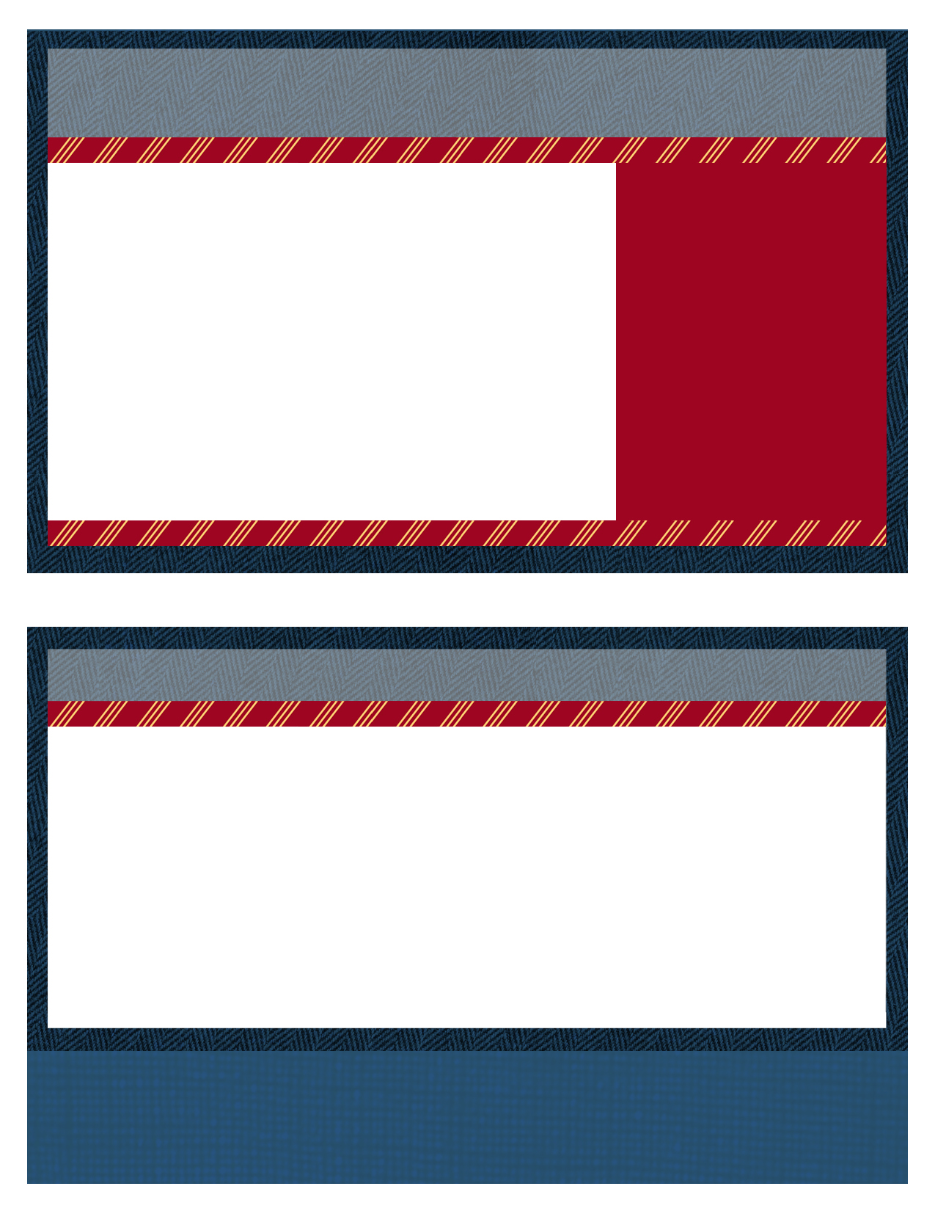

|  |  |
| --- | --- |
|  | If you have any questions or comments regarding the meeting please feel free to contact DeeDee McNeill at any of the below addresses or telephone numbers.  **DeeDee McNeill**, Nuclear Suppliers Association **Phone**: (401) 637-4224  **E-mail**: deedeemcneill@nuclearsupplier.org |

**Board of Directors**

Chairman – Joe Coughlin

joseph.coughlin@constellation.com

Vice Chairman – Kinsey Boehl

kinsey.boehl@nexteraenergy.com

Secretary – Bob French

bob.french@evergy.com

Treasurer – Frank Owens

frank.owens @constellation.com

**Steering Board**

Dave Martin

david.r.martin@xcelenergy.com

Avril Stewart

agstewart@tva.gov

Angela Williams

angela.williams@aps.com

Michelle Williams

miwillia@southernco.com

**Chattanooga, Tn**



**RP-ALARA Association Vision:** The RP-ALARA Association is committed to continual improvement in radiation protection standards and performance at our utilities.

2022 RP-ALARA Association Summer Meeting

Chattanooga, Tn

Mon. June 20 - Wed. June 22, 2022

News for New and Returning Members

While many of you are longstanding attendees of the RP-ALARA Association meetings, some of you may be attending for the first time. We would like to take this opportunity to provide you with information that will assist you in preparing for this meeting.

The RP-ALARA Association Conference is designed to facilitate the open sharing of industry knowledge through Operational Experience. The Association continually evaluates industry products and services with exposure impacts and shares experiences: e.g., shutdown chemistry, operating chemistry, chemical decon, zinc injections, micro filtration, and mechanical decon equipment to effectively manage our individual utility resources.

At this meeting, you will find industry best practices for site dose ownership, compare dose reduction strategies utilized at represented utilities, and obtain new ideas in regard to motivating and recognizing the work force to reduce overall site exposure.

We hope this interface with other ALARA members to make industry contacts, share knowledge and gain strategies will help further reduce exposures at your facility.

Welcome to the 2022 RP-ALARA Association Summer Meeting

2nd Day Agenda - Tuesday, June 21

07:00 – 08:00Breakfast with Vendors – Plaza AB

08:00 – 08:05 Meeting Overview (Joe Coughlin)

08:05 – 08:10 Safety Message (Michelle Williams)

08:10 – 08:20 Association Group Picture

08:20 – 09:40 Breakout Sessions by Plant Type

(Document Successes & Challenges

and a Golden Nugget)

* 4 Loop Westinghouse Group 1 (Joe Coughlin)
* 4 Loop Westinghouse Group 2 (Bob French)
* 2 Loop & 3 Loop Westinghouse (Kinsey Boehl)
* B & W, CE and BWR’s (Frank Owens)

09:40 – 10:00 Break / Vendor Interface (Report to Break out Rooms after break)

1st Day Agenda - Monday , June 20

Things to Consider:

* Benchmark question solicitation - Typically the group makes a list of 3 - 4 questions, which will be discussed roundtable fashion later in the meeting.
* Plant Status Forms – Please submit these to allow for quick benchmark references amongst the group.
* High Interest Topic Sheets - Another way to solicit industry feedback. Just list your question on a provided form and we will pass it around to gather answers.
* Vendor Presentations - A short presentation from each vendor.
* Breakout Session (Document Successes) - What works well at your plant? Please come prepared to share at least two items during this session.

Special Note: We want to welcome your family and traveling companions to join us for lunch and after meeting (evening) receptions!



2:00 – 2:30 pm Meeting Registration – Plaza C Foyer

2:30 – 3:15 pm Opening Ceremonies & Introduction – Plaza C

* Welcome – Opening Remarks (Joe Coughlin)
* Safety Review – Building Escape Routes (Kinsey Boehl)
* Safety Message – (Dave Martin)
* Introduction of NSA Representative – (Rick McCormick)
* Introductions of Board Members (Joe Coughlin)
* Introduction of Association Members (All)
* Association Secretary Report (Bob French)
* Association Treasury Report (Frank Owens)
* Establish Meeting Expectations/Review Agenda & Meeting Book Contents (Joe Coughlin)
* Benchmark Question Solicitation & High Interest Topic Sheets (Angela Williams)
* Elections this meeting (Joe Coughlin)

3:15 – 4:15 pm Presentation (EPRI)

4:15 – 4:20 pm Adjourn Day 1 (Joe Coughlin)

4:30 – 4:50 pm Steering Committee Meeting

5:00 – 6:30 pm Opening Reception & Vendor Displays – Plaza AB

C:\Documents and Settings\dlp8236\Local Settings\Temporary Internet Files\Content.IE5\WQXX73G0\MC900024040[1].wmf *C:\Documents and Settings\dlp8236\Local Settings\Temporary Internet Files\Content.IE5\B8PH5033\MC900241089[1].wmf C:\Documents and Settings\dlp8236\Local Settings\Temporary Internet Files\Content.IE5\ISDIQPTK\MC900242025[1].wmf*

2022 RP-ALARA Association Summer Meeting

Suggestions on Technical Presentations or specific speakers are welcome.

More Things to Think About:

Breakout Session (Document Challenges & a Golden Nugget) - What is your site's biggest challenge? Please come prepared to share this item.

AND what one thing do you consider your site does well...perhaps you have some new process you have determined works really well or you've discovered some new technology...that just may be your Golden Nugget. (Typically, Golden Nuggets are inexpensive and easy to implement)

MC900216564[1]

Please come prepared to discuss your Golden Nugget.

10:00 – 11:30 Breakout Session by Plant Type (Document Successes & Challenges and a Golden Nugget)

* + - * 4 Loop Westinghouse Group 1 (Joe Coughlin)
      * 4 Loop Westinghouse Group 2 (Bob French)
      * 2 Loop & 3 Loop Westinghouse (Kinsey Boehl)
      * B & W, CE and BWR’s (Frank Owens)

11:30 - 11:40 Break (Report to conference room after break)

11:40 – 12:30 Vendor Presentations

12:30 – 1:30 Lunch

1:30 – 2:30 Vendor Presentations

2:30 – 2:45 15 Minute Break

2:45 – 3:15 Vendor Presentations (Remaining vendors)

3:15 – 3:45 Presentation

3:45 – 3:50 End of Day Comments / Adjourn Day 2

4:00 – 4:30 Steering Committee Meeting

5:00 – 6:30 Vendor Reception – Plaza AB

* **RP-ALARA - Association Vision and Principles**
* **RP-ALARA - Association By-Laws**
* **VENDOR - Code of Conduct**
* **RP-ALARA - Board of Directors Code of Conduct**

Will enter more data here

See RP-ALARA Website for additional rp alara information

2022 RP/ALARA Association Summer Meeting

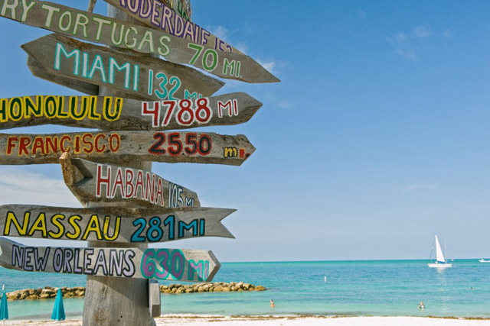

2nd Day Agenda Continued...

Make sure you visit all Vendor Displays! Ensure your passport is signed for each display to be eligible for Passport Drawing prizes on Wednesday.

2:20 – 3:00 Round Table Topic Discussions

3:00 – 3:15 Closing Remarks and Update on 2023 Winter Mtg

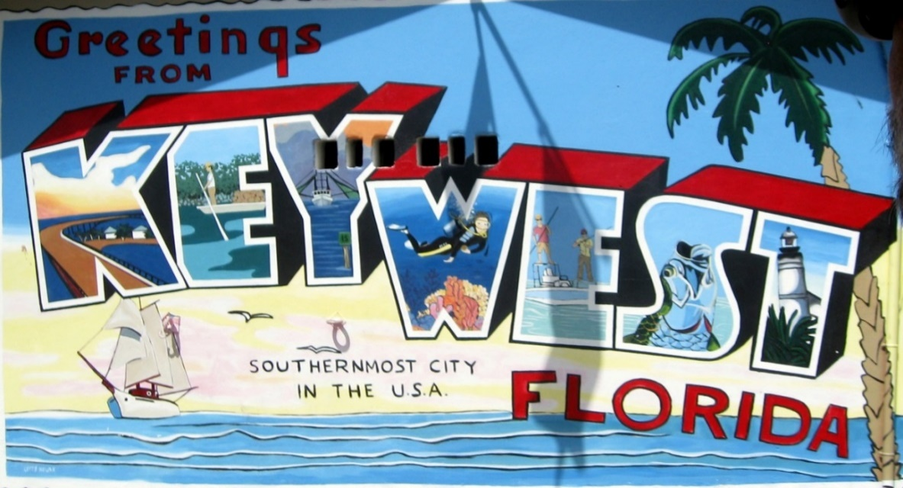

Key West, Fl. June 23-25, 2023

3:30 – 4:30 Steering Committee Post-Meeting

* Opening Remarks
* Welcome New Members
* Review Meeting Critique Sheets
* New Business

07:30 – 08:30 Breakfast with Vendors – Plaza AB

08:30 – 08:35 Safety Message (Angela Williams)

08:35 – 09:40 Breakout Session Review (Successes, Challenges and Nuggets)

09:40 – 09:50 10 Minute Break

09:50 – 10:35 Breakout Session Review (Successes, Challenges and Nuggets)

10:35 – 11:00 Break / Vendor Interface

11:00 – 12:00 Breakout Session Review (Successes, Challenges and Nuggets)

12:00 – 1:10 Lunch / Passport Drawing

1:10 – 2:10 Complete Breakout Session Review

2:10 – 2:20 10 Minute Break

3rd Day Agenda - Wednesday, June 22

What other information would you like to see in this newsletter?

Please contact Joe Coughlin at joseph.coughlin@constellation.com to provide feedback.

Thanks so much!

Please visit RP-ALARA.org for additional information. The official information source for RP- ALARA Association Members contains many useful links to web sites related to Nuclear Energy and other related sites.

We hope you have found this information to be useful in helping you prepare for your trip. We look forward to seeing you in June!

**2022 RP/ALARA Association Summer Meeting**