RP-ALARA Association Meeting Agenda

Chattanooga Tennessee - June 2022



**Sunday, June 19**

4:00 – 6:00 pm Steering Board Members - Pre-Meeting & Appetizers

**Note To all the RP-ALARA Association Representatives:**

This is to inform you that the RP-ALARA Association Meeting has been granted 1 CEC per contact hour to a maximum of 20 CEC and assigned ID 2019-00-001. This credit applies to calendar years 2020-2022.

Please be advised that contact hours do not include meals or business meetings without technical content.

As credit was requested for all participants, this assignment will be posted to the AAHP website.

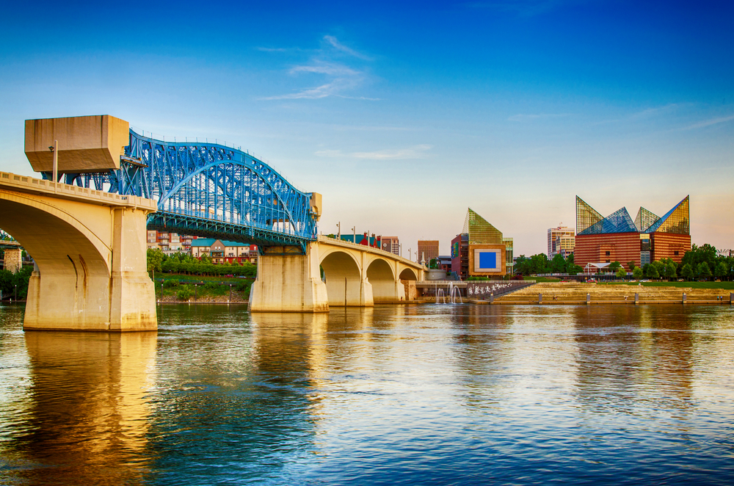

**Monday, June 20**

2:00 – 2:30 pm Meeting Registration – Plaza C Foyer

2:30 – 3:15 pm Opening Ceremonies & Introduction – Plaza C

* + - * Welcome – Opening Remarks (Joe Coughlin)
      * Safety Review – Building Escape Routes (Kinsey Boehl)
      * Safety Message – (Dave Martin)
      * Introduction of NSA Representative – (Rick McCormick)
      * Introductions of Board Members (Joe Coughlin)
      * Introduction of Association Members (All)
      * Association Secretary Report (Bob French)
      * Association Treasury Report (Frank Owens)
      * Establish Meeting Expectations/Review Agenda & Meeting Book Contents (Joe Coughlin)
      * Benchmark Question Solicitation & High Interest Topic Sheets (Angela Williams)
      * Elections this meeting (Joe Coughlin)

3:15 – 4:15 pm Presentation: EPRI Update – Daniel Wells

4:15 – 4:20 pm Adjourn Day 1 (Joe Coughlin)

4:30 – 4:50 pm Steering Committee Meeting

5:00 – 6:30 pm Opening Reception & Vendor Displays – Plaza AB

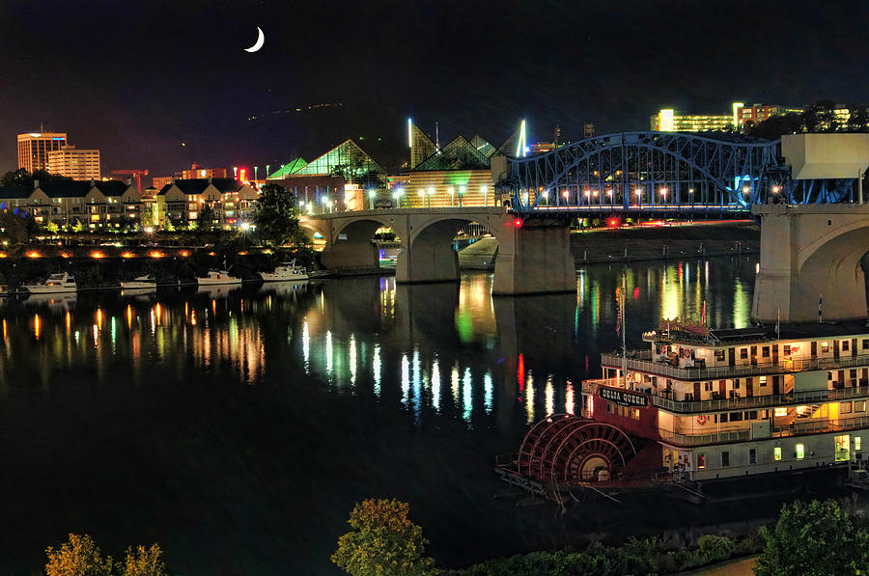

**Tuesday, June 21**

07:00 – 08:00Breakfast with Vendors – Plaza AB

08:00 – 08:05 Meeting Overview (Joe Coughlin)

08:05 – 08:10 Safety Message (Michelle Williams)

08:10 – 08:20 Association Group Picture

08:20 – 09:40 Breakout Sessions by Plant Type (Document Successes & Challenges and a Golden Nugget)

* + - * 4 Loop Westinghouse Group 1 (Joe Coughlin)
      * 4 Loop Westinghouse Group 2 (Bob French)
      * 2 Loop & 3 Loop Westinghouse (Kinsey Boehl)
      * B & W, CE and BWR’s (Frank Owens)

09:40 – 10:00 Break / Vendor Interface (Report to Break out Rooms after break)

10:00 – 11:30 Breakout Session by Plant Type (Document Successes & Challenges and a Golden Nugget)

* + - * 4 Loop Westinghouse Group 1 (Joe Coughlin)
      * 4 Loop Westinghouse Group 2 (Bob French)
      * 2 Loop & 3 Loop Westinghouse (Kinsey Boehl)
      * B & W, CE and BWR’s (Frank Owens)

11:30 - 11:40 10 Minute Break (Report to conference room after break)

11:40 – 12:30 Vendor Presentations

12:30 – 1:30 Lunch

1:30 – 2:30 Vendor Presentations

2:30 – 2:45 15 Minute Break

2:45 – 3:15 Vendor Presentations (Remaining vendors)

3:15 – 3:45 Presentation: Ultrasonic Decontamination – Joe Jaegers

3:45 – 3:50 End of Day Comments / Adjourn Day 2 (Joe Coughlin)

4:00 – 4:30 Steering Committee Meeting

5:00 – 6:30 Vendor Reception – Plaza AB

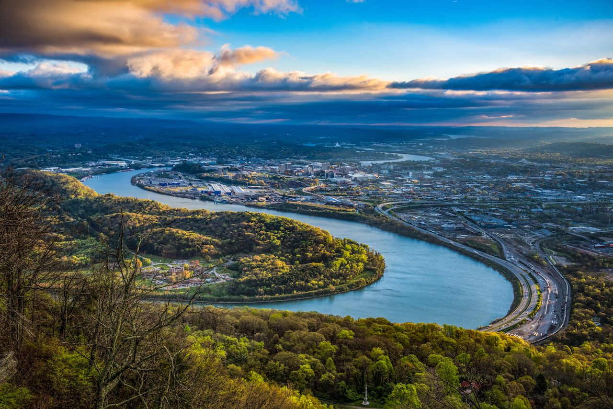

**Wednesday, June 22**

07:30 – 08:30 Breakfast with Vendors – Plaza AB

08:30 – 08:35 Safety Message (Angela Williams)

08:35 – 09:40 Breakout Session Review (Successes, Challenges and Golden Nuggets)

09:40 – 09:50 10 Minute Break

09:50 – 10:35 Continue Breakout Session Review (Successes, Challenges and Golden Nuggets)

10:35 – 11:00 Break / Vendor Interface

11:00 – 12:00 Continue Breakout Session Review (Successes, Challenges and Golden Nuggets)

12:00 – 1:10 Lunch / Passport Drawing

1:10 – 2:10 Complete Breakout Session Review (Successes, Challenges and Golden Nuggets)

2:10 – 2:20 10 Minute Break

2:20 – 3:00 Round Table Topic Discussions

3:00 – 3:15 Closing Remarks and Update on 2023 Winter Meeting (Key West Florida)

**January 2023**

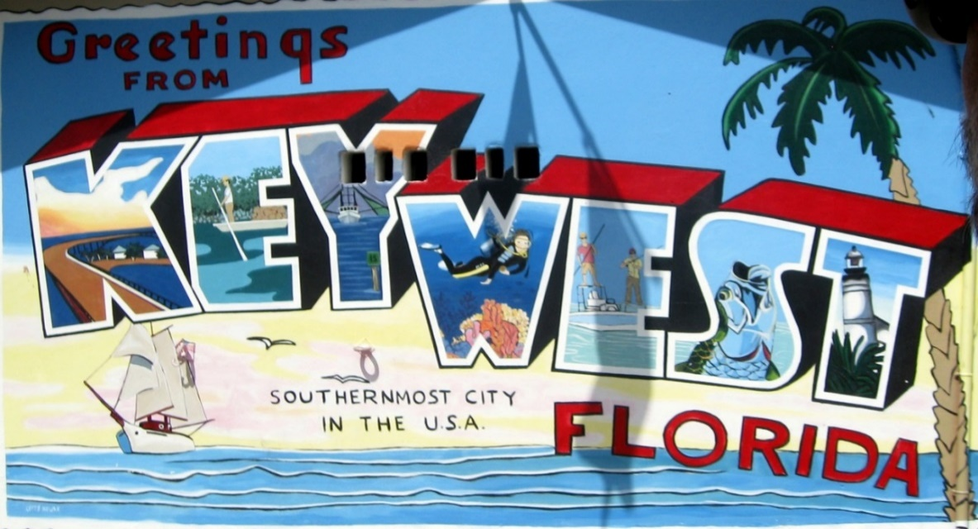

3:30 – 4:30 Steering Committee Post-Meeting

* Opening Remarks
* Welcome New Members
* Review Meeting Critique Sheets
* New Business