RP-ALARA Association Meeting Agenda

Charlotte NC - June 2023



**Sunday, June 18**

4:00 – 6:00 pm Steering Board Members - Pre-Meeting & Appetizers

**Note To all the RP-ALARA Association Representatives:**

This is to inform you that the RP-ALARA Association Meeting has been granted 1 CEC per contact hour to a maximum of 20 CEC and assigned ID 2023-01-21-242. This credit applies to calendar years 2023-2026.

Please be advised that contact hours do not include meals or business meetings without technical content.

As credit was requested for all participants, this assignment will be posted to the AAHP website.

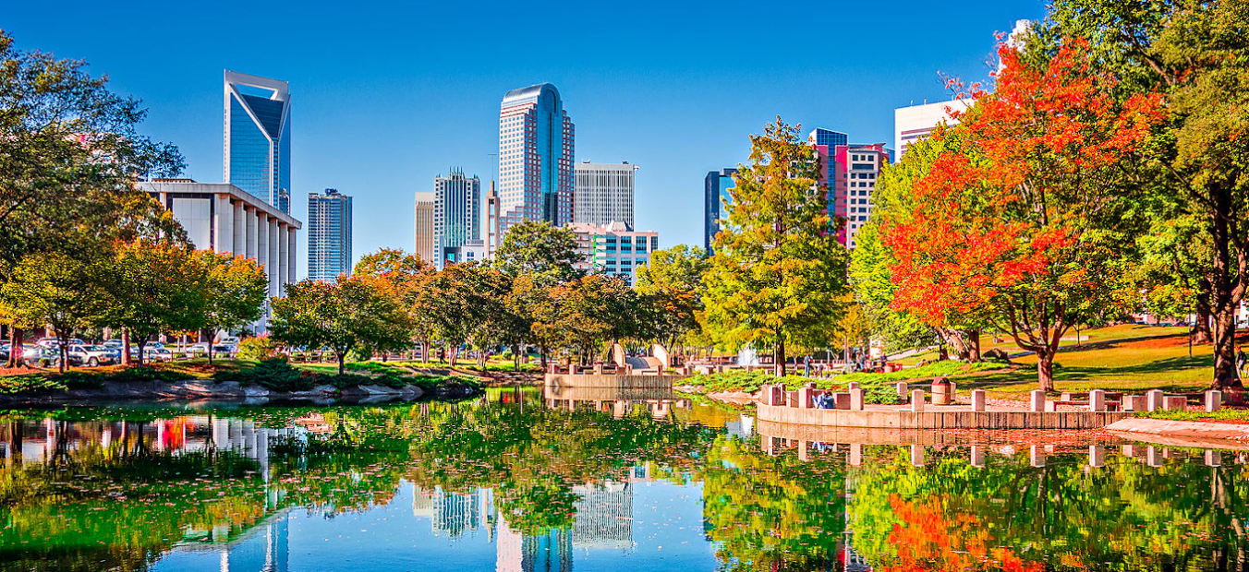

**Monday, June 19**

2:00 to 2:30 Meeting Registration with DeeDee McNeill – All

2:30 – 3:15 pm Opening Ceremonies & Introduction

* Welcome – Opening Remarks (Joe Coughlin)
* Safety Review – Building Escape Routes (Jeff Fontaine)
* Safety Message – (Jeff Fontaine)
* Introduction of NSA Representative – (Keith Lovendale)
* Introductions of Board Members (Joe Coughlin)
* Introduction of Association Members (All)
* Association Secretary Report (Jonah Morgan)
* Association Treasury Report (Joe Coughlin)
* Establish Meeting Expectations/Review Agenda & Meeting Book (Joe Coughlin)
* Benchmark Question Solicitation & High Interest Topic Sheets (Scott Leach)
* Elections this meeting (Joe Coughlin)

3:15 – 3:45 pm Presentation: Lane Waddell - EPRI RP/Alara Update

3:45 – 3:50 pm Adjourn Day 1 (Joe Coughlin)

4:00 – 4:50 pm Steering Committee Meeting

5:00 – 6:30 pm Opening Reception & Vendor Displays

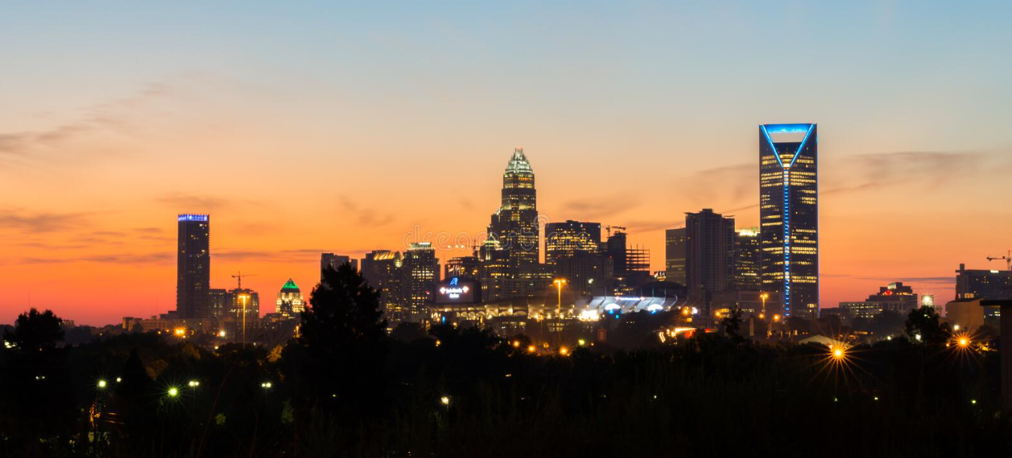

**Tuesday, June 20**

**07:00 – 08:00 Breakfast with Vendors**

08:00 – 08:05 Meeting Overview (Joe Coughlin)

08:05 – 08:10 Safety Message (Scott Leach)

08:10 – 08:20 Association Group Picture

08:20 – 09:40 Breakout Sessions by Plant Type (Document Successes & Challenges and a Golden Nugget)

* 2 Loop & 3 Loop Westinghouse (John Hertz)
* 4 Loop Westinghouse (Joe Coughlin)
* B&W and ICE (Jonah Morgan)
* BWR’s and CE (Scott Leach)

09:40 – 10:00 Breakout/Vendor Interface

10:00 – 11:30 Breakout Session by Plant Type (Document Successes & Challenges and a Golden Nugget)

* 2 Loop & 3 Loop Westinghouse (John Hertz)
* 4 Loop Westinghouse (Joe Coughlin)
* B&W and ICE (Jonah Morgan)
* BWR’s and CE (Scott Leach)

11:30 - 11:40 **10 Minute Break**

11:40 – 12:30 Vendor Presentations

12:30 – 1:30 **Lunch**

1:30 – 2:30 Vendor Presentations

2:30 – 2:40 **10 Minute Break**

2:40 – 3:10 Vendor Presentations (Remaining vendors)

3:10 – 3:40 Presentation: Bob French – Cavity Decon

3:40 – 3:50 Vote for New Board Member

3:50 – 3:55 End of Day Comments / Adjourn Day 2

4:00 – 4:30 Steering Committee Meeting

5:00 – 6:30 Vendor Reception

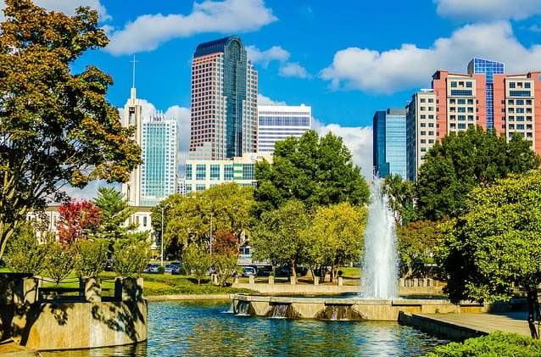

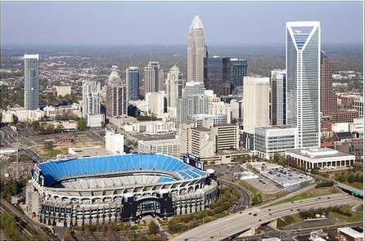

**Wednesday, June 21**

08:00 – 09:00 Breakfast with Vendors

09:00 – 09:05 Safety Message (Jonah Morgan)

09:05 – 09:10 Voting Results for New Board Member (Joe Coughlin)

09:10 – 10:35 Breakout Session Review (Successes, Challenges & Golden Nuggets)

* B&W and ICE (Jonah Morgan)

10:35 – 11:00 **Break / Vendor Interface**

11:00 – 12:00 Breakout Session Review (Successes, Challenges & Golden Nuggets)

* 2 Loop & 3 Loop Westinghouse (John Hertz)

12:00 – 1:10 **Lunch /** **Passport Drawing**

1:10 – 2:10 Breakout Session Review (Successes, Challenges and Golden Nuggets)

* BWR’s and CE (Scott Leach)
* 4 Loop Westinghouse (Joe Coughlin)

2:10 – 2:20 **Break**

2:20 – 3:00 Round Table Discussions

3:00 – 3:15 Closing Remarks and Update on 2024 Winter Meeting

* Key West – January 22-24, 2024

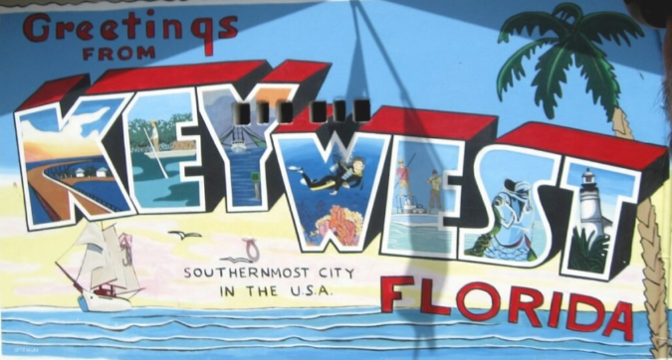

3:30 – 4:30 Steering Committee Post-Meeting

* Opening Remarks
* Welcome New Members
* Review Meeting Critique Sheets
* New Business