 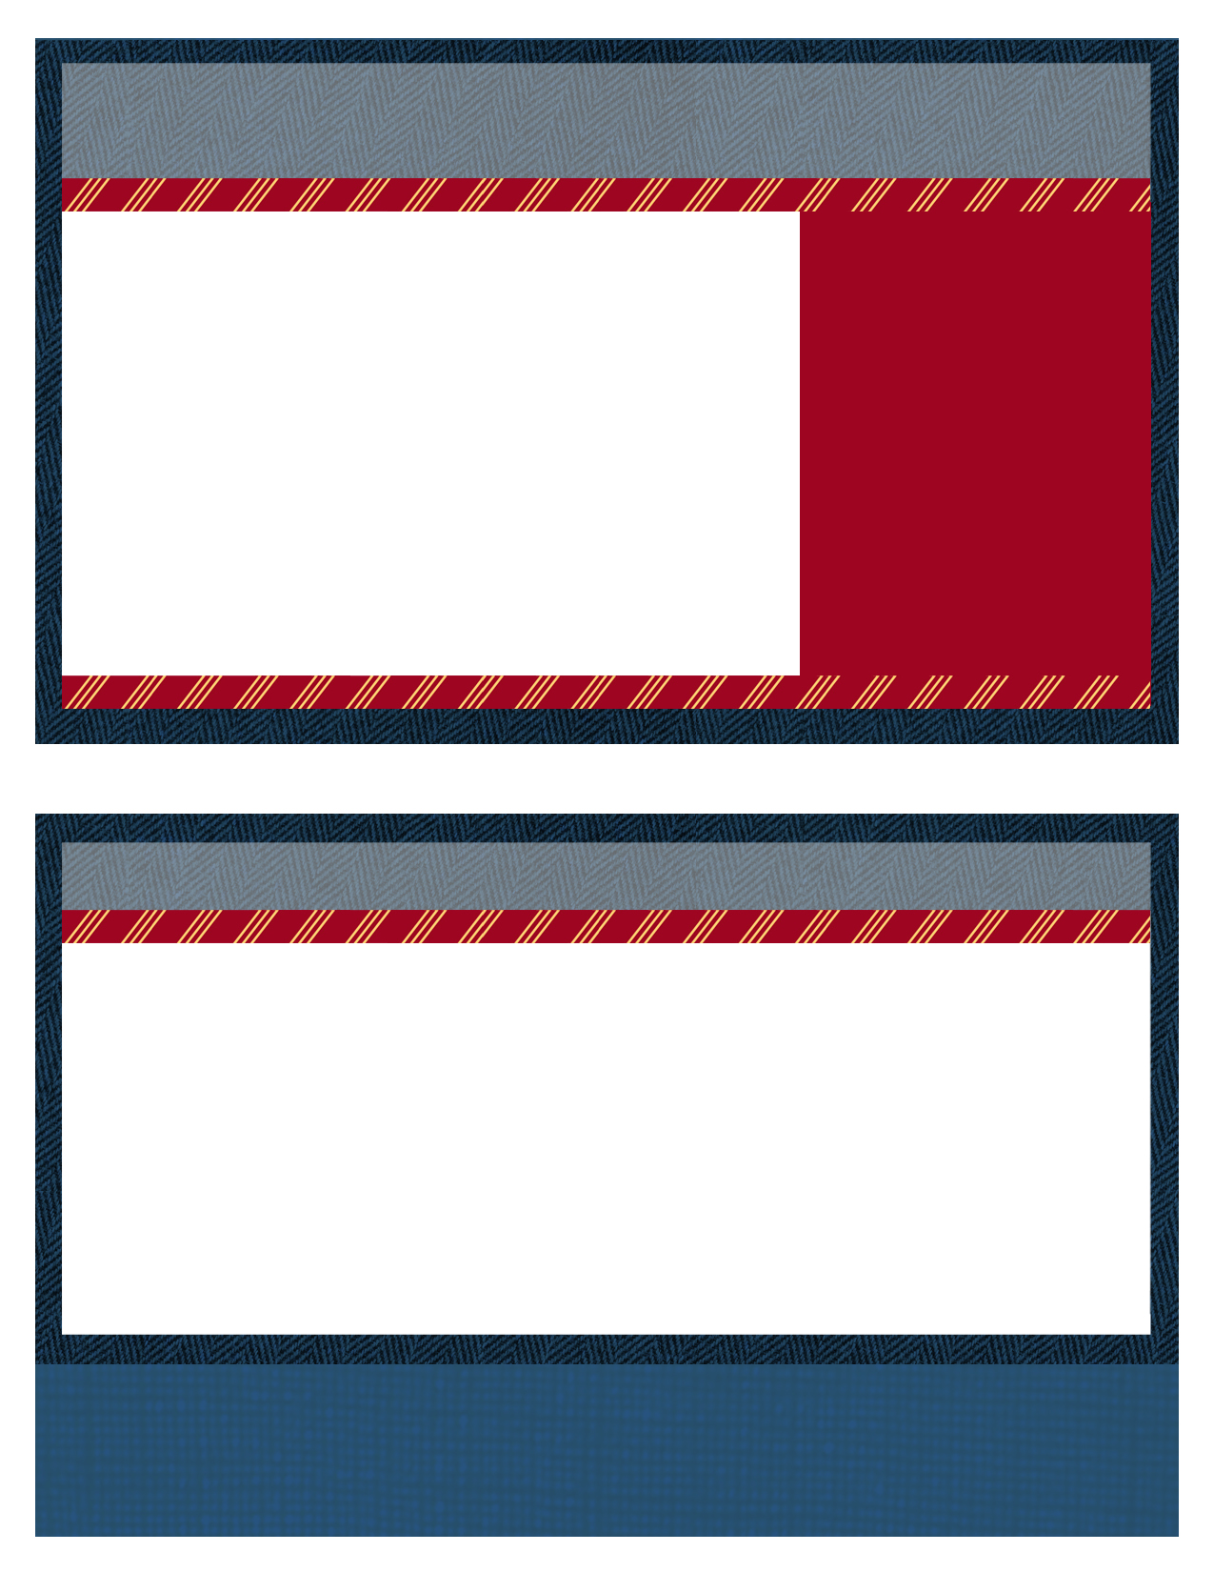

|  |  |
| --- | --- |
|  | If you have any questions or comments regarding Association dues or business, please feel free to contact any of the Board Members or DeeDee McNeill at the following; **DeeDee McNeill** (509) 551-1808 or **E-mail :** [rp.alara.assn@gmail.com](mailto:rp.alara.assn@gmail.com)  If you have any questions or comments regarding the meeting or logistics, please feel free to contact any of the Board Members or Amanda Ray at the following; Amanda Ray (615) 400-4016 or **E-mail**: Amanda@partinandassociates.com |

**Board of Directors**

Chairman – Joe Coughlin

joseph.coughlin@constellation.com

Vice Chairman – John Hertz

jjhertz@tva.gov

Secretary – Jonah Morgan

jbmorgan@stpegs.com

Treasurer – Frank Owens

frank.owens@constellation.com

**Steering Board**

Bob French

bob.french@evergy.com

Scott Leach

scott.leach@constellation.com

Dave Martin

david.martin@xenuclear.com

Kevin Weirich

kaweirich@tva.gov

**Past Chairman/Advisor**

Jeff Fontaine

jfontaine58@outlook.com

**Key West**

[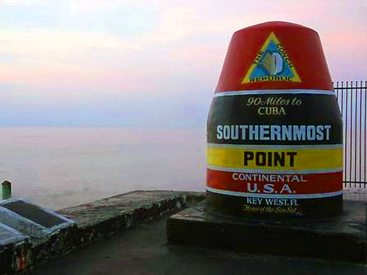](http://www.google.com/url?sa=i&rct=j&q=&esrc=s&source=images&cd=&cad=rja&uact=8&ved=0ahUKEwj9x4qmycrJAhUX22MKHYJhAVcQjRwIBw&url=http://keystv.com/dynamic/index.php?id%3D814&psig=AFQjCNHf9EX9HilxETZcyIJZILNl_dMg6g&ust=1449605671525188)

**RP-ALARA Association Vision:** The RP-ALARA Association is committed to continual improvement in radiation protection standards and performance at our utilities.

2024 RP-ALARA Association Meeting

Key West, FL

Mon. January 22 - Wed. January 24, 2024

News for New and Returning Members

While many of you are longstanding attendees of the RP-ALARA Association meetings, some of you may be attending for the first time. We would like to take this opportunity to provide you with information that will assist you in preparing for this meeting.

The RP-ALARA Association Conference is designed to facilitate the open sharing of industry knowledge through Operational Experience. The Association continually evaluates industry products and services with exposure impacts and shares experiences: e.g., shutdown chemistry, operating chemistry, chemical decon, zinc injections, micro filtration, and mechanical decon equipment to effectively manage our individual utility resources.

At this meeting, you will find industry best practices for site dose ownership, compare dose reduction strategies utilized at represented utilities, and obtain new ideas in regard to motivating and recognizing the work force to reduce overall site exposure.

We hope this interface with other ALARA members to make industry contacts, share knowledge and gain strategies will help further reduce exposures at your facility.

Welcome to the 2024 RP-ALARA Association Winter Meeting

Special Note: We want to welcome your family and traveling companions to join us for lunch and after meeting (evening) receptions!



2:00 - 2:30 pm Meeting Registration – All

2:30 – 3:15 pm Opening Ceremonies & Introduction

* Welcome – Opening Remarks (Joe Coughlin)
* Safety Review – Building Escape Routes (John Hertz)
* Safety Message – (John Hertz)
* Introduction of NSA Representative – (Keith Lovendale)
* Introductions of Board Members (Joe Coughlin)
* Introduction of Association Members (All)
* Association Secretary Report (Jonah Morgan)
* Association Treasury Report (Frank Owens)
* Establish Meeting Expectations/Review Agenda & Meeting Book Contents (Joe Coughlin)
* Benchmark Question Solicitation & High Interest Topic Sheets (Scott Leach)
* Elections this meeting (Joe Coughlin)

3:15 – 4:15 pm Presentation: Joseph Jaegers – Lasalle Bottom Head Drain Project

4:15 – 4:20 pm Adjourn Day 1 (Joe Coughlin)

4:30 – 4:50 pm Steering Committee Meeting

5:00 – 6:30 pm Opening Reception & Vendor Displays

1st Day Agenda - Monday , January 22

07:00 – 08:00 Breakfast with Vendors

08:00 – 08:05 Meeting Overview (Joe Coughlin)

08:05 – 08:10 Safety Message (Scott Leach)

08:10 – 08:20 Association Group Picture

08:20 – 09:40 Breakout Sessions by Plant Type (Document Successes & Challenges and a Golden Nugget)

* 2 Loop & 3 Loop Westinghouse (John Hertz)
* 4 Loop Westinghouse (Joe Coughlin)
* B&W and ICE (Jonah Morgan)
* BWR’s and CE (Scott Leach)

09:40 – 10:00 Breakout/Vendor Interface

2nd Day Agenda -Tuesday, January 23

Things to Consider:

* Benchmark question solicitation - Typically the group makes a list of 3 - 4 questions, which will be discussed roundtable fashion later in the meeting. Please consider if you have a question that where you would like industry feedback.
* High Interest Topic Sheets - Another way to solicit industry feedback. Just list your question on a provided form and we will pass it around to gather answers.
* Vendor Presentations - A short presentation from each vendor.
* Breakout Session (Document Successes) - What works well at your plant? Please come prepared to share at least two items during this session.

C:\Documents and Settings\dlp8236\Local Settings\Temporary Internet Files\Content.IE5\WQXX73G0\MC900024040[1].wmf *C:\Documents and Settings\dlp8236\Local Settings\Temporary Internet Files\Content.IE5\B8PH5033\MC900241089[1].wmf C:\Documents and Settings\dlp8236\Local Settings\Temporary Internet Files\Content.IE5\ISDIQPTK\MC900242025[1].wmf*

2024 RP-ALARA Association Meeting

Suggestions on Technical Presentations or specific speakers are welcome.

10:00 – 11:30 Breakout Session by Plant Type (Document Successes & Challenges and a Golden Nugget)

* 2 Loop & 3 Loop Westinghouse (John Hertz)
* 4 Loop Westinghouse (Joe Coughlin)
* B&W and ICE (Jonah Morgan)
* BWR’s and CE (Scott Leach)

11:30 - 11:40 10 Minute Break (Report to Salon C after break)

11:40 – 12:30 Vendor Presentations

12:30 – 1:30 Lunch

1:30 – 2:30 Vendor Presentations

2:30 – 2:40 10 Minute Break

2:40 – 3:10 Vendor Presentations (Remaining vendors)

3:10 – 3:40 Presentation: John Hertz – Dose Reporting and Data Mining

3:40 – 3:50 Vote for New Board Member

3:50 – 3:55 End of Day Comments / Adjourn Day 2

4:00 – 4:30 Steering Committee Meeting

5:00 – 6:30 Vendor Reception

More Things to Think About:

Breakout Session (Document Challenges & a Golden Nugget) - What is your site's biggest challenge? Please come prepared to share this item. AND what one thing do you consider your site does well...perhaps you have some new process you have determined works really well or you've discovered some new technology...that just may be your Golden Nugget. (Typically, Golden Nuggets are inexpensive and easy to implement)

MC900216564[1]

Please come prepared to discuss your Golden Nugget.

See RP-ALARA Website for additional rp alara information

* [**RP/ALARA - Association Vision and Principles**](http://www.pwralara.org/code-vision.htm)
* [**RP/ALARA - Association By-Laws**](http://www.pwralara.org/docs/PWR-ALARA-bylaws.doc)
* [**VENDOR - Code of Conduct**](http://www.pwralara.org/code-vendor.htm)
* [**RP/ALARA - Board of Directors Code of Conduct**](http://www.pwralara.org/code-steering.htm)

Will enter more data here

2024 RP/ALARA Association Meeting

[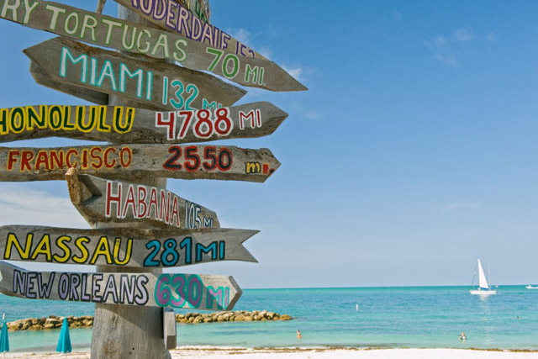](http://www.google.com/url?sa=i&rct=j&q=&esrc=s&source=images&cd=&cad=rja&uact=8&ved=0ahUKEwie_vS5yMrJAhUQw2MKHdN_CbAQjRwIBw&url=http://keywest.com/todo.html&psig=AFQjCNHf9EX9HilxETZcyIJZILNl_dMg6g&ust=1449605671525188)

2nd Day Agenda Continued...

Make sure you visit all Vendor Displays! Ensure your passport is signed for each display to be eligible for Passport Drawing prizes on Wednesday.

2:10 – 2:20 Break

2:20 – 3:00 Round Table Discussions

3:00 – 3:15 Closing Remarks and

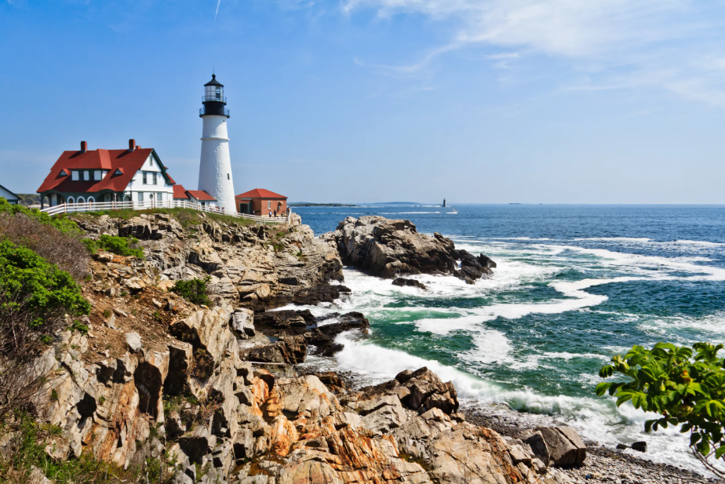

Update on Summer 2024 Mtg

3:30 – 4:30 Steering Committee Post-Meeting

* Opening Remarks
* Welcome New Members
* Review Meeting Critique Sheets
* New Business

08:00 – 09:00 Breakfast with Vendors

09:00 – 09:05 Safety Message (Bob French)

09:05 – 09:10 Voting Results for New Board Member (Joe Coughlin)

09:10 – 10:35 Breakout Session Review (Successes, Challenges & Golden Nuggets)

* BWR’s and CE (Scott Leach)
* 4 Loop Westinghouse (Joe Coughlin)

10:35 – 11:00 Break / Vendor Interface

11:00 – 12:00 Breakout Session Review (Successes, Challenges & Golden Nuggets)

* 2 Loop & 3 Loop Westinghouse (John Hertz)

12:00 – 1:10 Lunch / Passport Drawing

1:10 – 2:10 Breakout Session Review (Successes, Challenges and Golden Nuggets)

* B&W, and ICE (Jonah Morgan)

3rd Day Agenda - Wednesday, January 24

What other information would you like to see in this newsletter?

Please contact Joe Coughlin at joseph.coughlin@constellation.com to provide feedback.

Thanks so much!

Please visit RP-ALARA.org for additional information. The official information source for RP- ALARA Association Members contains many useful links to web sites related to Nuclear Energy and other related sites.

We hope you have found this information to be useful in helping you prepare for your trip. We look forward to seeing you in January!

**2024 RP/ALARA Association Meeting**